Review of the Structure of the Scottish Local Government Pension Scheme
CONSULTATION RESPONSE FORM
Instructions
Responses in this form should be drafted in conjunction with the accompanying consultation report. To respond, please complete the respondent details and as many of the consultation questions your organisation wishes to complete and return the form via email to the Pensions Institute at consultation@pensions-intitute.org no later than Friday, 7 December 2018.
This consultation is being conducted in electronic form only, so responses must be emailed; hard copy posted or delivered responses cannot be received. Any queries about the consultation should be addressed to Matthew Roy, Fellow, Pensions Institute at matthew.roy@pensions-institute.org.

RESPONDENT DETAILS
Name of responding organisation(s)  Please list the full name of each organisation  participating in this response. | Organisation type  Is your organisation an administering authority, employer, or employee group? Please record for each responding organisation.
Dundee City Council | Participating Employer of Tayside Pension Fund
Authors  Please list any people that wish to be recorded as authors of this response, including name, job title and organisation. | Consent  Please confirm each author consents to their information being retained for analysing the consultation responses by writing ‘confirm’ by their name.
Gregory Colgan, Executive Director of Corporate Services | confirm
Date  Please date the response. | 3/12/18

Covering information
If you wish to include covering information with your response, please include the text here. The text can wrap onto additional pages if needed.
Dundee City Council is the administering authority and a participating employer of Tayside Pension Fund.
See below for key information about Tayside Pension Fund as at 30th June 2018:
Membership | Active Members: 19,004  Deferred Members: 13,442  Pensioners: 15,786  Total Membership: 48,232
No. Employers | 46
Portfolio Value | £3.87bn
Investment Performance | 3yr: 11.6% p.a.  5yr: 11.37% p.a.  10yr: 9.3% p.a.  Investments have out-performed benchmarks in all time periods above.
Funding | Estimated funding level (assets / liabilities) 107% (net of 10% volatility reserve).
Employer Contribution Rate | 17% since April 2014 (reduced from 18%)

See next page the key information about Dundee City Council as an employer as at 31st March 2018:
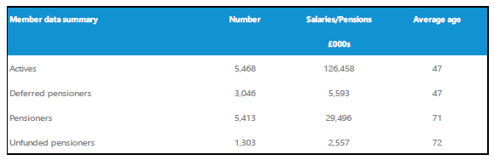

The consultation questions follow.
CONSULTATION QUESTIONS

Question 1: Retain the current structure with 11 funds

The text can wrap onto additional pages.
- Cost of investing:
How well informed do you feel about the investment costs in your fund? What information do you rely on to specify and measure these?
As the officers and Pensions Sub-Committee Members are employed DCC or are DCC elected members, the Council feel that we have a full understanding and are well informed about the investment costs of the fund.
Perhaps an easy measure for any employer to assess the costs being incurred within the fund is that of the level of contribution they are being asked to pay as if this is low, then they can be reassured that both returns are adequate and costs are controlled. To this, DCC is comfortable with having the 2nd lowest contribution rate within the Scottish LGPS at 17%.
Dundee City Council (DCC) is comfortable that Tayside Pension Fund (TPF) have complied with CIPFA guidance on accounting for Local Government Pension Scheme Management Expenses.
Whilst admittedly TPF have little / no complex asset classes or products that are accused of having “hidden costs”, all investment management costs are recognised, measured and disclosed in the Fund Account in line with the guidance, therefore for the products within the TPF portfolio, we are comfortable with the level of knowledge of fund costs.
Whilst the annual investment reviews are undertaken independently (that assess fee levels) are not within the public realm, DCC is represented within the Committee who have sight of the information and have opportunity to challenge if fees are not in line with peers or industry average. Furthermore, at employers forums, the fund officers provide presentation on fund performance and costs.
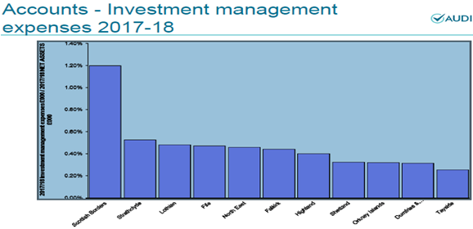
How well does the current system manage investment costs?
The Scheme Advisory Board (SAB) structural review report refers to The Financial Conduct Authority’s (FCA) recent Asset Management Market Study, which highlights a number of weaknesses in the current asset management system in the UK. These include weak price competition, a lack of transparency, and a lack of alignment of fees and performance. DCC believe that these issues apply particularly to small, retail investors, and as Local Government Pension Scheme (LGPS) funds are all large investors, are reassured that the report confirmed are able to negotiate very effectively and get good value for money.
Whilst there is always room for improvement, it is clear that LGPS are subject to greater levels of scrutiny and transparency to their corporate counterparts. All LGPS investment services are subject to tender, and in addition to the requirements to meet public sector procurement guidance, there is additional scrutiny through the governance framework and public accountability from members and employers through the closeness to the funds that they are stakeholders in.
How would you improve the measurement and management of investment costs in the current system?
The introduction of the Transparency Code, MiFID II (the Markets in financial Instruments Directive) and other market initiatives have improved measurement and management, however these have been recent and in cases only considered best practice.
As a participating employer within TPF, DCC would support mandatory compliance with all relevant codes of practice and initiatives where applicable to the relevant asset classes in order to ensure consistency and transparency.
- Governance:
How well informed do you feel about the governance of your fund? What information do you rely on to measure this?
TPF is administered by Dundee City Council as the administering authority with responsibility for the management of the fund delegated to the Tayside Pension Sub-Committee. This Sub-Committee meets quarterly and oversees the supervision and administration of the fund’s investments, sets the investment strategy and also oversees pension administration. The day to day operational matters are further delegated in the main to the Executive Director of Corporate Services. This governance structure includes all the mandatory elements introduced by the Public Service Pensions Act 2013.
As a result of further legislative changes to the governance arrangements in relation to pension schemes within the public sector, The Pension Board was established on 1st April 2015 and is separate from the Pension Sub-Committee. The Pension Board are responsible for assisting in securing compliance with the regulation and other legislation relating to the governance and administration of the Scheme and also the requirements of the Pensions Regulator.
The role of the Pension Board is to assist TPF in complying with all of the legislative requirements and making sure that the scheme is being efficiently & effectively governed and managed.
The Pension Board members work in conjunction with the officers of TPF to ensure DCC that the pension scheme is well managed and administered, and that scheme members get the best service. The local Pension Board must have an equal number of scheme member and scheme employer representatives and board members are appointed for a term of 5 years (in line with local government election cycle).
In light of the above, DCC is comfortable that TPF has appropriate governance statements and policies in place which are available within a defined area of the TPF website as well as within the annual report of the fund.
DCC is comfortable with the level of effectiveness of TPF’s governance as it is measured annually by external auditors. Audit Scotland has reported within their own annual audit report that TPF has effective governance arrangements in place that support scrutiny of decisions made by the Pension Sub-committee. Furthermore, DCC is reassured that decisions are transparent with committee papers and detailed minutes of meetings of the Pension Sub-committee available on the Dundee City Council's website and all policies and strategies available on the TPF website.
How well is the current system governed?
DCC is aware that the current system of governance in the Scottish LGPS was only recently introduced - in 2015. It was the result of extensive review by a UK government commission leading to primary legislation and new scheme regulations.
In 2016, the Scottish Public Pensions Agency (SPPA) commissioned KPMG to undertake a review of the arrangements. The review’s findings overall were positive and no fundamental weaknesses were identified, although KPMG made a number of recommendations aimed at helping the new Boards establish their purpose.
All boards are now in place, and although DCC would not wish to comment on other funds governance arrangements, DCC believe that TPF has a strong governance structure which is not overly complex. This governance not only applies to investment, but to the overall management of the scheme and ensures accountability for all aspects of pension fund management. DCC is confident that TPF are adequately resourced, and the broad representation of skills and knowledge across the Officers, Committee and the Board ensures appropriate challenge and accountability for decision making and performance monitoring and management. Specialist independent advisors ensure effectiveness and efficiency.
Whilst DCC is aware that it has been stated that those involved in the governance and administration of funds have vested interests due to potential adverse effects of any structure change, DCC believe that the focus should remain primarily on the members and employers of the fund as it is also stated that changes to the structure could affect employers directly, with contributions levels being impacted by changed investment returns as a result of having a change of strategy imposed, or indeed, a change of management, which has poorer performance than they have benefited from in the past. DCC is concerned that some employers may not be able to accommodate any rise in contribution rates, and whilst a change in structure should not affect member’s benefits directly, if investment returns are significantly lower, this may occur (as has been the case for the University Superannuation Scheme).
DCC is aware that some believe the governance of the SLGPS to be inefficient, due to the volumes of people across the country involved in the Pensions Committee and Pension Boards, but believe that this was the structure designed by the UK Government to support close ties with stakeholders, and although admittedly some of the people involved at the beginning had limited knowledge and experience of pension matters, the officers, advisors and experienced members of Committees have provided support and guidance. DCC believe that the introduction of pensions boards in addition to pension committees has improved the scrutiny and communication of the fund with its stakeholders.
DCC is aware that statements have been made regarding Councils acting as Administering Authorities bring governance issues including limited involvement of stakeholders and conflicts of interest for both officer and elected members. DCC believe that there is no evidence of this and furthermore believe that TPF (as well as all other Scottish funds) have appropriate policies and controls in place to prevent this.
How would you improve governance of the current system?
DCC believe that recommendations from the KPMG review should continue to be worked through and implemented.
Whilst each fund is subject to scrutiny through its own governance and audit, some believe that there is a lack of consistency of information which makes it difficult for stakeholders to judge the effectiveness of their fund, and of the Scheme as a whole. These concerns have been addressed by the recent initiatives such as the LGPS Transparency Code, introduction of Pensions Boards and increased collaboration and co-investment between funds which is helping to further improve governance and manage costs. DCC’s recommendation would be that these measures should be allowed time to be incorporated into standard operating practice prior to making further assessment or recommendation in this area.
How important is it to maintain a local connection with respect to oversight and strategy?
DCC believe that the LGPS represents both significant benefit for scheme members, but also considerable cost for employers. Local connection is essential to ensure that both employers and members can exercise meaningful oversight, and that investment and funding strategies are fully aligned and tailored to their own membership requirements. DCC believe that the closeness to its stakeholders has had positive impact on the performance of the fund overall as the closeness to the employers and membership enables face to face communication and better understanding of local circumstances.
How would you determine if the benefits of a local connection in governance outweigh the benefits of scale?
DCC believe that there is absolutely no evidence to suggest that the current model is fundamentally flawed. Indeed, the LGPS in Scotland is a considerable success story.
DCC believe that TPF already enjoys considerable benefits of scale in terms of cost at a value of almost £4bn. This is demonstrated by the independent annual reviews undertaken by Audit Scotland with the lowest investment management expenses regardless of size:
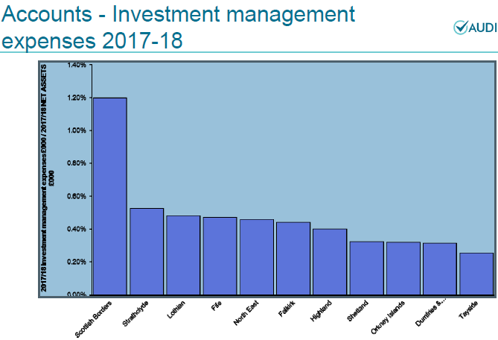
Furthermore TPF have the second lowest administration and oversight costs as proportion of net assets. DCC believe that the local scrutiny and accountability are crucial in maintaining value for money.
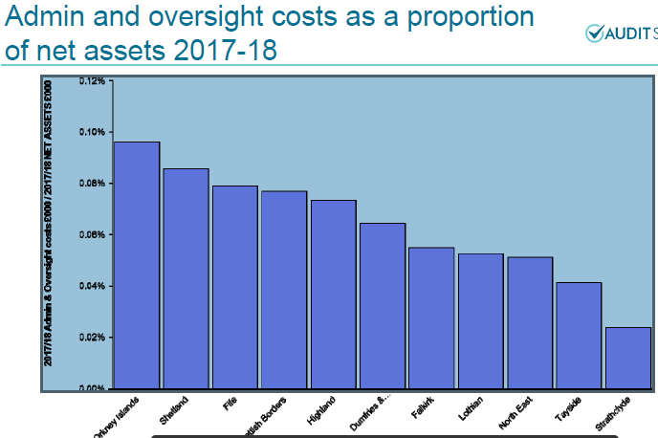
Whilst there are various figures being quoted in way of potential savings in investment management costs that would be achieved by merging into one large fund, these figures are assuming internal investment management, but do not provide insight as to impact on investment returns.
In terms of administration and oversight, there is no huge correlation as to economies of scale that would have such an impact as to warrant fund merger.
In 2017/18, the following performance across funds was captured by Audit Scotland. From this we can see that there are a range of returns, but these are in no way correlated to in-house, or larger schemes.
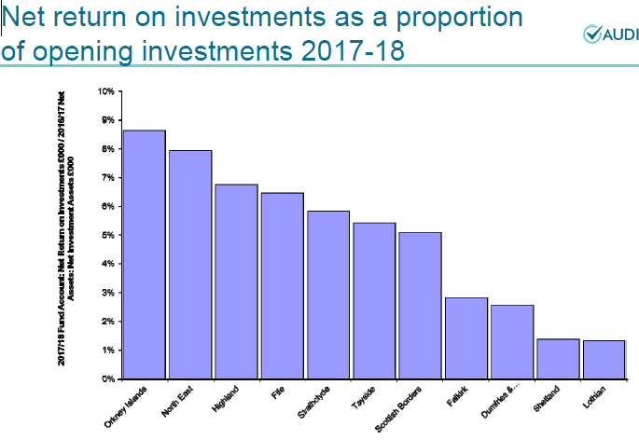
- Operating risks:
How well informed do feel about the operating risks of your fund? What information do you rely on to specify and measure these?
As an employer, DCC is aware that TPF have a detailed risk register which is subject to continual appraisal and quarterly review by the TPF Sub-Committee and Board. The risk register is publicly available both on the TPF website and within the minutes of the meetings on Dundee City Council website. The full risk register is also published within the Annual Report.
Whilst it is mooted that there are key person risk within smaller funds, DCC believe TPF to have sound and solid governance in place to ensure that there is adequate speciailist resource available to assist if required, whether it be by senior officer, investment advisor or from support and guidance in the short term from other funds.
How well are operating risks managed in the current system?
As noted above, DCC believe TPF to have a strong focus on the identification, analysis and management of risk. Employers are aware of the Investment and funding strategies that are designed to manage specific risks, and that there are controls built into processes to ensure that risks are managed appropriately and proportionately.
DCC as participating employers, are aware of the risk monitoring with investment managers (who are contractually bound to have robust compliance and risk management resource) is undertaken quarterly, and external analysis is also undertaken by investment consultants and auditors.
DCC believe that having 11 funds in operation with differing investment strategies provides suitable diversification and risk management for the Scottish LGPS and the employers within. DCC believe that the greater the fund size, the harder the task of diversification and thus the increase of risk to the membership of the fund. This is a key point that managers of larger, successful funds point out as once too big the risk of diseconomies of scale grows as the bigger the fund, the more inflexible it is to manage.
How would you improve the measurement and management of operating risks in the current system?
DCC believe that scheme benefits and the application of these are a key area which could benefit from improvement. The regulations associated with scheme benefits have over the years become more and more complex. At present there are in effect 3 benefit schemes in operation (1/80th, 1/60th, 1/49th) as well as numerous administering body and employer discretions available through the differing regulations. This complexity significantly increases operating risks associated with administering benefits.
The introduction of the cost cap which may result in further change to benefit regime will only complicate this further. DCC would support any means of simplification of LGPS benefits and discretions to enable greater standardisation in administration and thus better management of risk.
- Infrastructure:
How well informed do you feel about your fund’s investments in infrastructure? What information do you rely on?
DCC is aware that TPF have ability within investment strategy to allocate 10% of fund to local and alternative opportunities, of which infrastructure forms part of. DCC is also aware that TPF have engaged KPMG (TPF investment advisors) to assess market conditions in line with the risk and return profile and requirements of the fund to develop a bespoke strategy to progress investment within this broader asset class.
How do you rate the current system’s ability to invest in infrastructure?
DCC believe that infrastructure investment requires a sound understanding of risk, return and governance characteristics. In terms of size, DCC is aware that TPF are not constrained as big enough to support large scale investment, but are aware that infrastructure is relatively illiquid, supply-constrained and expensive, so believe that care and caution must be exercised.
How would you increase investment in infrastructure in the current system?
DCC believe that investment in infrastructure could increase if the supply of attractive opportunities increased, or the risk/return characteristics were improved. More simple investment structures would also assist.
- Do you have any additional comments about this option?
DCC believe that it is worth re-iterating that the LGPS in Scotland is a success story. Funds have solid and stable management and their closeness to their own stakeholders has enabled investment strategies to be tailored to the needs of individual funds in meeting their liabilities.
The Scottish funds are all close to or above 100% funded meaning that their primary objective has been achieved. The LGPS in Scotland has for very many years been better funded than its equivalent in England and the rest of the UK. The Government Actuary Department’s (GAD) Section 13 report analysed all Scottish funds on a standard basis demonstrates this strong position, but also that fund’s don’t necessarily have to be big to be successful. The following graph over the page by GAD provides further evidence.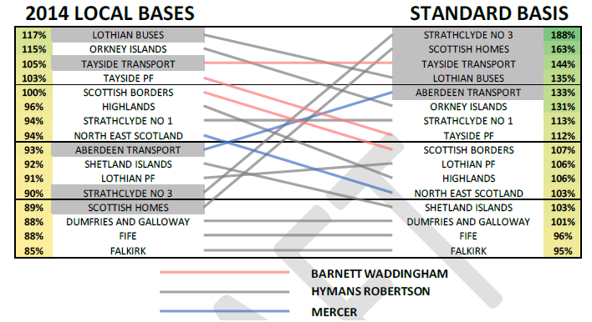
DCC do not believe that the evidence above is in line with implications that the Scottish local government pension scheme is not well managed, or providing value for money.
DCC believe that Funds will need to adapt to address the challenges identified within the Scheme Advisory Board report, but these challenges do not stem from the current structure, and revising the structure is unlikely to be a panacea for them.

Question 2: Promote cooperation in investing and administration between the 11 funds
The text can wrap onto additional pages.
- Cost of investing:
What impact do you think promoting agreements between funds would have on investment costs?
DCC think that this is potentially the largest area that could deliver improvements both in terms of costs and in quality of performance.
What would be the positive impacts?
  - Financial savings (fees and services)
  - Better information to facilitate more informed decision making
  - Reduced resource requirements across all funds
What would be the negative impacts?
None.
- Governance:
What impact do you think promoting agreements between funds would have on governance?
No significant impact on individual governance structures, but may lead to better outcomes.
What would be the positive impacts?
Reduced duplication of governance effort. Improved collective governance of the scheme, creating a more collaborative culture across funds.
What would be the negative impacts?
No negative impacts, but the need to co-ordinate activity and decision-making could be a complication until such arrangements bed down.
- Operating risks:
What impact do you think promoting agreements between funds would have on operating risks?
None
What would be the positive impacts?
Could have positive impact in relation to managing risks across the funds.

What would be the negative impacts?
None
Infrastructure:
What impact do you think promoting agreements between funds would have on funds’ ability to invest in infrastructure?
  - Ability for funds without experience in alternative asset classes to benefit from the experience and expertise of others.
  - Reduced costs of legal, consultancy and due diligence required.
  - Standardised and potentially better quality information to facilitate more informed, and better decision making
What would be the positive impacts?
Potential financial savings, and facilitating wider diversification across asset classes
What would be the negative impacts?
None
- Do you have any additional comments about this option?
DCC is aware that there is already significant co-operation between the Scottish funds and that a wider LGPS network already exists.
DCC is aware that the LGPS (UK) National Frameworks in place are widely used for a range of services including actuarial, investment consultancy, stewardship, global custody, performance and cost monitoring, legal, transition management and third party administration services.
DCC is also aware of Scottish LGPS framework agreements that have been put in place for portfolio management, member tracing, and scheme administration, and that the introduction of LGPS 2015, and the associated member and employer communications, was a large-scale collaborative exercise between all the Scottish funds.
DCC however believe that there is undoubtedly scope and willingness to build further on these initiatives.

Question 3: Pool investments between the 11 funds
The text can wrap onto additional pages.
- Cost of investing:
What impact do you think pooling investments between funds would have on the cost of investing?
DCC is aware that TPF already enjoys significant benefits of scale and is very effective in ensuring lowest cost investment fees as demonstrated in independent assessments by Audit Scotland, therefore DCC believe that further efficiencies in existing mandates are unlikely to be achieved through adding further scale. DCC is of the opinion that pooling would be detrimental to the TPF investment strategy as it would result in limiting the ability to meet investment objectives. Investment mandates are specifically selected in order to complement each other with the aims of achieving the required investment objectives to provide adequate returns (at an acceptable level of risk) to meet the overall TPF pension liabilities.
DCC believe that there would be an additional layer of bureaucracy and cost, as well as a loss in ability to make the optimal investment decisions for the benefit of the funds members and employers. This could have significant impact on the level of contributions that are currently paid, therefore increasing the cost to employer. The lower the contribution, the more reassurance that employers have both returns are adequate and costs are controlled. To this, DCC is comfortable with having the 2nd lowest contribution rate within the Scottish LGPS at 17%.
The complex pool structures in England and Wales demonstrate this additional bureaucracy and costs:
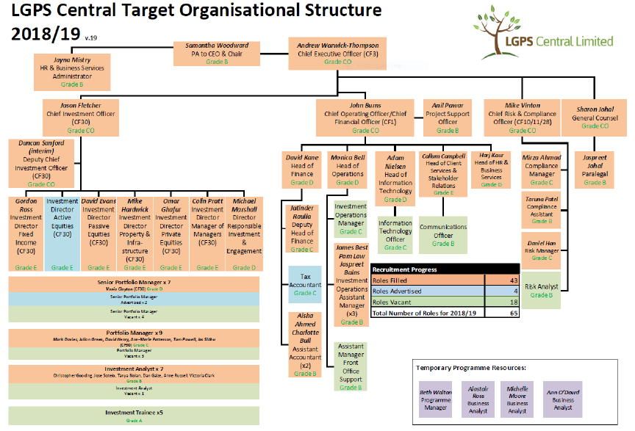
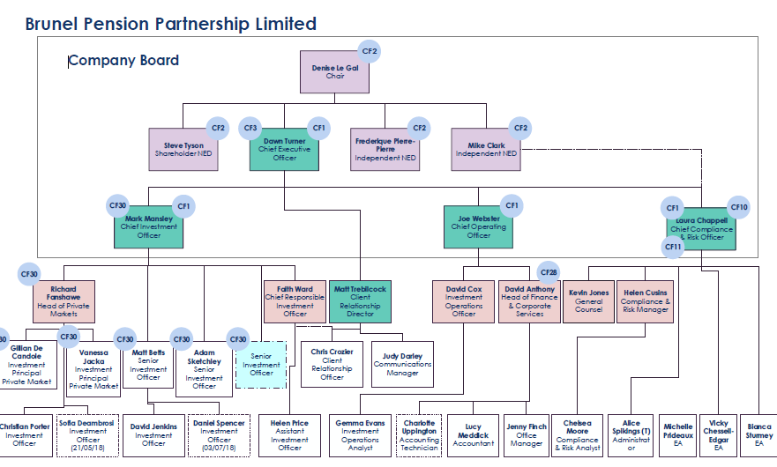
What would be the positive impacts?
DCC believe any positive impacts to be unlikely, but believe the costs to be significant.
What would be the negative impacts?
DCC believe that reducing cost is only a positive impact if it improves net returns, and there is no evidence that costs have actually been reduced in England and Wales. Cost reduction through pooling would be a negative if it led to a restricted choice of investment options, and reduced returns or increased risk.
DCC believe the ultimate negative impact would be when restricted choice led to reduced returns and failure to best meet the investment objectives of the funds members and employers, and there was a detrimental impact on the funding level and subsequently on employer contribution.
The risk that employers may not be able to accommodate any rise in contribution rates, and whilst a change in structure should not affect members benefits directly, if investment returns are significantly lower, this may occur (as has been the case for the University Superannuation Scheme).
If asset pooling were possible, under what circumstances should a fund consider joining an asset pool?
DCC believe that a fund should only be embarking upon this arrangement if stakeholders unanimously believed that the decision to pool is in the best interests of their members to whom they have fiduciary duty to act in their best interest. DCC do not believe that pooling would be in the best interest of their members.
Under which circumstances should the SLGPS consider directing funds to pool?
DCC believe that pooling should be considered if there was clear evidence that funds were unable to manage and failed to meet their investment objectives and there was potential for detrimental impact to members and employers.
- Governance:
What impact do you think pooling investments between funds would have on governance?
Where pools oversee external investment managers, this represents an additional layer of governance between the fund and the manager. DCC believe that this is likely to reduce transparency and complicate governance (see organizational charts of the large complex structures in place in England and Wales above).
Also, where pools manage investments internally, DCC believe that the funds may become captive – i.e. it would be difficult to replace the internal management team if they underperformed.
What would be the positive impacts?
DCC do not consider there to be any potential positive impacts.
What would be the negative impacts?
  - Cost of set up and maintenance
  - Resource to establish and maintain
  - Loss of flexibility which could have negative impact in meeting objectives and ultimately in costing more to employers / and member benefits
- Operating risks:
What impact do you think pooling investments between funds would have on operating risks?
  - Pools with external managed funds - Potentially increased operating risks as there would be the existing operating risks of the managers, but then a new layer of risks associated with management of the pool.
  - Pools with internally managed funds – Increased risk management and compliance resources would be required to enable comparative effectiveness with external management (who are managing considerably more funds than LGPS, and have global resources and expertise to do so).
What would be the positive impacts?
DCC do not consider there to be any potential positive impacts.
What would be the negative impacts?
  - Financial cost
  - Detrimental impact on resources
  - Concentration of risk
- Infrastructure:
What impact do you think pooling investments between funds would have on funds’ ability to invest in infrastructure?
DCC believe there to be very little impact, if any. Varying sized funds invest in infrastructure, it largely depends on the fund’s choice of investment.
DCC believe that pooling investments might facilitate infrastructure investment by funds who currently don’t, but across the Scottish funds, the potential increase in allocation to this asset class would not materially change the total investment in infrastructure.
What would be the positive impacts?
DCC believe that a combined initiative by the Scottish funds to invest in infrastructure could have some merit. The recent report by the Scottish Futures Trust (SFT) on Scottish Real Asset Investments and the Local Government Pension Scheme identifies an area of investment that “enables LGPS to meet their fiduciary duties with good risk adjusted returns that are not highly sought after or competed for by other investors: as those investments are not highly competed for by other investors, investment in them will provide a level of additionality to the Scottish real asset stock, and where they relate to new developments, they will provide additional Scottish capital stock.”
DCC stress though that:
- the positive impacts identified by SFT are not related to the objectives of the LGPS and its funds; and
- it would not be necessary to pool funds in their entirety to facilitate investment in infrastructure. The creation of a pooled investment vehicle in which funds could invest would achieve this if the vehicle was sufficiently attractive on a risk/return assessment.
What would be the negative impacts?
  - Large set up costs
  - Potential FCA authorization requirement
Do you have any additional comments about this option?
DCC believe that it is much too early to judge whether the pooling initiatives of England and Wales have been successful in meeting their objectives, however what is clearly apparent that is that this has been a costly and time consuming exercise with no standardised approach or clearly planned strategy. The payback period for costs incurred is likely to span many years and it is also likely to be some time until the pools settle fully into their new structures as all pools differ in set up, structure and objectives.
DCC is aware that the pooling of England and Wales has also had detrimental impact on stripping resources from administering authorities who still require skills and resources, therefore potentially increasing risk of detrimental impact in the management of the funds.
DCC is clear in their considerations that infrastructure investment is not the primary objective of the LGPS, and thus fiduciary duty must be considered if considering pooling the funds simply to achieve more infrastructure investment in infrastructure.
DCC do not support the approach used in England and Wales, but believe that there might be some merit in more selective pooling, on a voluntary basis either of individual asset classes or by specific groups of funds, dependant on wishes of those individual funds in order to meet their requirements.

Question 4: Merge the funds into one or more new funds
The text can wrap onto additional pages.
Cost of investing:
What impact do you think mergers between funds would have on the cost of investing?
Answer as for pooling at 3.a, above.
What would be the positive impacts?
Answer as for pooling at 3.a, above.
What would be the negative impacts?
Answer as for pooling at 3.a, above, but the transitional costs would be much greater.
DCC is very aware that changes to the structure could, however, affect employers directly – their contribution rates are impacted by investment returns and funding. The potential impact of “what could happen” is demonstrated below following the 2014 valuation:
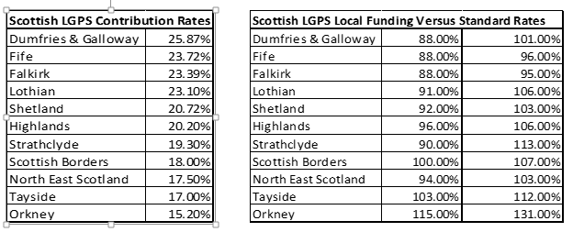
Some fund employers would not be able to accommodate change to contribution rates, furthermore, and as this increased contribution would be as a result as a drop in funding level, this would not be in the best interest of the scheme membership.
In light of the above risks, DCC could not support any option which could result in an increase in contribution rates which would be unaffordable. A 1% increase in employer contribution level would result in an estimated increase in pension costs of £4m for Dundee City Council.
If merging were possible, under what circumstances should a fund consider a merger?
DCC believe that any fund merger should only be considered if 2 or more individual funds (and their stakeholders) believe this option to be in the best interests of their members and employers.
Under what circumstances should the SLGPS consider directing funds to merge?
Answer as for pooling at 3.a, above.
Governance:
What impact do you think mergers between funds would have on governance?
DCC believe that a merger would inevitably reduce or remove local involvement in pension fund governance which is believed to be intrinsic to the successful performance of TPF. The degree of this would depend on the model and extent of the merger.
What would be the positive impacts?
DCC believe that whilst a merged model would require less governance resource than individual governance models, this is only truly a positive if the merged model is proven to be more effective.
What would be the negative impacts?
DCC believe that a merged model would increase the reliance on a smaller number of individuals, and in so, significant increase in risk.
Operating risks:
What impact do you think mergers between funds would have on operating risks?
DCC believe that a fund merger would inevitably result in concentration of risk, and reduced diversification. However, if 2 or more funds did believe merger to be beneficial for their individual circumstances, this should still be a key consideration for them, but them in isolation.
DCC believe that whilst there are opinions of the potential savings a full merger of Scottish funds might may have, it may be worth noting that there has been no balance in assessing the impact of potential failure on the collective membership and employers due to the decisions of a reduced number of individuals. DCC do not consider size as a guarantee of success, and the impact of failure would be catastrophic for the country.
What would be the positive impacts?
DCC do not consider there to be any potential positive impacts.
What would be the negative impacts?
- Concentration of risk.
- Impact of failings
- Loss of flexibility
- Reliance on a reduced number of people
Infrastructure:
What impact do you think mergers between funds would have on funds’ ability to invest in infrastructure?
DCC believe that a full merger of Scottish funds could increase investment in infrastructure, but only if the investment strategy required this. Investment strategies are set to meet risk and return objectives, not to facilitate an investment in a favoured asset class.
- What would be the positive impacts?
DCC believe that a merged fund or funds could potentially make larger individual infrastructure investments.
What would be the negative impacts?
DCC believe that larger individual investments would represent a greater concentration of risk.
Do you have any additional comments about this option?
DCC is of the opinion that a merger into one fund would be likely to break the direct link between the scheme and local government by taking the fund out of local government control; and whilst a fund of this size would undoubtedly enjoy some benefits of scale (in certain asset classes), size is not a guarantor, nor necessarily a determinant of success.
The UK’s 2 largest pension funds are the Universities Superannuation Scheme (USS) and the British Telecom Pension Scheme (BTPS). Both have assets of around £50 billion (a little more than the combined value of the Scottish LGPS funds). Both are very well managed in many respects. Yet both have significant funding deficits – in excess of £10 billion in each case – and are contemplating, or have effected closure of their schemes to new defined benefit accrual.

Question 5: Preferred and additional options
The text can wrap onto additional pages.
- Which option does your organisation prefer? Please explain your preference.
DCC is of the opinion that TPF already enjoys considerable benefits of scale in terms of cost which is demonstrated by the independent annual reviews undertaken by Audit Scotland.
DCC is comfortable that TPF has in place an appropriate and effective governance structure and risk management processes.
DCC do not believe that it is clear what would be gained by members or employers from the proposed alternative models of pooled or merged funds. It is certain, though, that there would be significant costs and risks associated with any change, and any pooling or merger of funds should only occur where individual funds are in agreement that this would be to the benefit of their members and employers.
DCC is patently aware that TPF has a low contribution rate which is based upon the localised asset and liability profile of the fund, its underlying funding position and bespoke investment strategy, and whilst protection would be sought to retain this should the pooling or merger option be chosen as the optimal structure, there is no guarantee that any future investment strategy determined at larger scale would sustain this. The risks that a change of structure that could result in a rise in employer contribution rates, and in turn a potential change in benefits would not be supported by DCC as this would not be in the best interest of the scheme membership. DCC believe pension provision to be a very long-term undertaking, and that any structural development should be clearly focused on the long-term sustainability.
DCC as an employer support TPF’s preferred option to develop a more collaborative structure (option 2) which could generate advantages across all funds without disruption, transitional cost and likely unintended consequences that merging or pooling would produce.
DCC is aware the Scottish LGPS has established communications networks between funds (both investment and administration), but that the current focus is largely on information sharing and problem-solving rather than structural development. DCC would support TPF in welcoming the opportunity to collaborate in areas such as investment opportunities; procurement; ESG & governance issues; administration.
- What other options should be considered for the future structure of the LGPS?
DCC believe that collaborative initiatives might include the following:
- development of a forward-looking programme to consider potential initiatives such as:
  - joint investment, including in infrastructure
  - joint or framework procurement
  - joint or shared diligence
- joint engagement on environmental, social or governance issues
- shared communications and administration (e.g. GMP) where applicable.
- a regular, formalised meeting of fund conveners
- What would be the advantages and disadvantages of these other option for funds’ investment costs, governance, operating risks and ability to invest in infrastructure?
DCC believe that the development of collaborative base as suggested above, could generate many of the advantages of the individual options identified without the disruption, transitional cost and likely unintended consequences that selecting and mandating one option would produce.
- Are there any other comments you would like to make?
DCC believe that pension provision is a very long-term undertaking, and the prime objective is to act in the best interest of the members in order to meet their requirements, therefore any structural change should be clearly strategically focused on the long-term benefits of the members rather than any external objectives.
DCC believe that a fund should only be embarking upon arrangement to pool or merge if stakeholders unanimously believe that the decision is in the best interests of their members to whom they have fiduciary duty to act in their best interest. DCC do not believe that pooling or merging would be in the best interest of their members.
DCC is very aware that changes to the structure could, however, affect employers directly – their contribution rates are impacted by investment returns and funding. Some fund employers would not be able to accommodate change to contribution rates, furthermore, and which would be as a result as a drop in funding level would not be in the best interest of the scheme membership.
In light of the above risks, DCC could not support any option which could result in an increase in contribution rates which would be unaffordable.

The consultation questions end.

