Review of the Structure of the Scottish Local Government Pension Scheme
CONSULTATION RESPONSE FORM
Instructions
Responses in this form should be drafted in conjunction with the accompanying consultation report. To respond, please complete the respondent details and as many of the consultation questions your organisation wishes to complete and return the form via email to the Pensions Institute at consultation@pensions-intitute.org no later than Friday, 7 December 2018.
This consultation is being conducted in electronic form only, so responses must be emailed; hard copy posted or delivered responses cannot be received. Any queries about the consultation should be addressed to Matthew Roy, Fellow, Pensions Institute at matthew.roy@pensions-institute.org.

RESPONDENT DETAILS
Name of responding organisation(s)  Please list the full name of each organisation  participating in this response. | Organisation type  Is your organisation an administering authority, employer, or employee group? Please record for each responding organisation.
Dundee City Council (Tayside Pension Fund) | Administering Authority
Authors  Please list any people that wish to be recorded as authors of this response, including name, job title and organisation. | Consent  Please confirm each author consents to their information being retained for analysing the consultation responses by writing ‘confirm’ by their name.
Gregory Colgan, Executive Director of Corporate Services | confirm
Date  Please date the response. | 3/12/2018

Covering information
If you wish to include covering information with your response, please include the text here. The text can wrap onto additional pages if needed.
Dundee City Council is the Administering Authority for Tayside Pension Fund.
See below for key information about Tayside Pension Fund as at 30th June 2018:
Membership | Active Members: 19,004  Deferred Members: 13,442  Pensioners: 15,786  Total Membership: 48,232
No. Employers | 46
Portfolio Value | £3.87bn
Investment Performance | 3yr: 11.6% p.a.  5yr: 11.37% p.a.  10yr: 9.3% p.a.  Investments have out-performed benchmarks in all time periods above.
Funding | Estimated funding level (assets / liabilities) 107% (net of 10% volatility reserve).
Employer Contribution Rate | 17% since April 2014 (reduced from 18%)

The consultation questions follow.
CONSULTATION QUESTIONS

Question 1: Retain the current structure with 11 funds

The text can wrap onto additional pages.
- Cost of investing:
How well informed do you feel about the investment costs in your fund? What information do you rely on to specify and measure these?
The officers and Pensions Sub-Committee Members consider that they have a full understanding and are well informed about the investment costs of the fund.
Tayside Pension Fund (TPF) have complied with CIPFA guidance since its 2014 publication “Guidance on Accounting for Local Government Pension Scheme Management Expenses”. Whilst admittedly TPF have little / no complex asset classes or products that are accused of having “hidden costs”, all investment management costs are recognised, measured and disclosed in the Fund Account in line with the guidance, therefore for the products within the TPF portfolio, there is comfort with the level of knowledge of fund costs.
How well does the current system manage investment costs?
The Scheme Advisory Board (SAB) structural review report refers to The Financial Conduct Authority’s (FCA) recent Asset Management Market Study, which highlights a number of weaknesses in the current asset management system in the UK. These include weak price competition, a lack of transparency, and a lack of alignment of fees and performance. These issues apply particularly to small, retail investors (i.e. the thousands of small DC schemes with a handful of members). In this context, Local Government Pension Scheme (LGPS) funds are all large investors, which the report confirmed are able to negotiate very effectively and get good value for money.
All LGPS investment services are subject to tender, and in addition to the requirements to meet public sector procurement guidance, there is additional scrutiny through the governance framework and public accountability from members and employers. Whilst there is always room for improvement, it is clear that within this industry, LGPS are subject to greater levels of scrutiny and transparency to their corporate counterparts.
How would you improve the measurement and management of investment costs in the current system?
The introduction of the Transparency Code, MiFID II (the Markets in financial Instruments Directive) and other market initiatives have improved measurement and management, however these have been recent and in cases only considered best practice.
TPF would support mandatory compliance with above where applicable to relevant asset classes in order to ensure consistency and transparency.
- Governance:
How well informed do you feel about the governance of your fund? What information do you rely on to measure this?
TPF is administered by Dundee City Council as the administering authority with responsibility for the management of the fund delegated to the Tayside Pension Sub-Committee. This Sub-Committee meets quarterly and oversees the supervision and administration of the fund’s investments, sets the investment strategy and also oversees pension administration. The day to day operational matters are further delegated in the main to the Executive Director of Corporate Services. This governance structure includes all the mandatory elements introduced by the Public Service Pensions Act 2013.
As a result of further legislative changes to the governance arrangements in relation to pension schemes within the public sector, The Pension Board was established on 1st April 2015 and is separate from the Pension Sub-Committee. The Pension Board are responsible for assisting in securing compliance with the regulation and other legislation relating to the governance and administration of the Scheme and also the requirements of the Pensions Regulator.
The role of the Pension Board is to assist the Tayside Pension Fund in complying with all of the legislative requirements and making sure that the scheme is being efficiently & effectively governed and managed.
The Pension Board members work in conjunction with Dundee City Council in its role as the administering authority and with officers of the Tayside Pension Fund to ensure that your pension scheme is being run properly and that you, as a scheme member, get the best service. The local Pension Board must have an equal number of scheme member and scheme employer representatives and board members are appointed for a term of 5 years (in line with local government election cycle).
TPF has appropriate governance statements and policies in place which are available within a defined area of the TPF website as well as within the annual report of the fund.
The effectiveness of TPF’s governance is measured annually by external auditors. Audit Scotland has reported within their own annual audit report that TPF has effective governance arrangements in place that support scrutiny of decisions made by the Pension Sub-committee. Furthermore, that decisions are transparent with committee papers and detailed minutes of meetings of the Pension Sub-committee available on the Dundee City Council's website.
How well is the current system governed?
The current system of governance in the Scottish LGPS was only recently introduced - in 2015. It was the result of extensive review by a UK government commission leading to primary legislation and new scheme regulations.
In 2016, the Scottish Public Pensions Agency (SPPA) commissioned KPMG to undertake a review of the arrangements. The review’s findings overall were positive and no fundamental weaknesses were identified, though KPMG made a number of recommendations addressed at helping the new Boards establish their purpose.
All boards are now in place, and although TPF would not wish to comment on other funds governance arrangements. We believe that TPF have a very simple but strong governance structure. This governance not only applies to investment, but to the overall management of the scheme and ensures accountability for all aspects of pension fund management. TPF are adequately resourced, and the broad representation of skills and knowledge across the Officers, Committee and the Board ensures appropriate challenge and accountability for decision making and performance monitoring and management. Specialist independent advisors are utilised as requested or required to ensure effectiveness and efficiency.
Whilst it has been stated that these parties have vested interests due to potential adverse effects of any structure change, the focus should remain primarily on the members and employers of the fund as it is also stated that changes to the structure could, however affect employers directly, with their contributions being impacted by changed investment returns as a result of having a change of strategy imposed, or indeed, a change of management, which has poorer performance than they have benefited from in the past. Employers may not be able to accommodate any rise in contribution rates, and whilst a change in structure should not affect members’ benefits directly, if investment returns are significantly lower, this may occur (as has been the case for USS).
Although some believe the governance of the SLGPS to be inefficient, due to the volumes of people across the country involved in the Pensions Committee and Pension Boards, this was the structure designed by the UK Government to support close ties with stakeholders, and although admittedly some of the people involved at the beginning had limited knowledge and experience of pension matters, the officers, advisors and experienced members of Committees have provided support and guidance.
Although it has been stated that Councils acting as Administering Authorities brings governance issues including limited involvement of stakeholders and conflicts of interest for both officer and elected members, there is no evidence of this and funds have appropriate policies and controls in place to prevent this.
How would you improve governance of the current system?
Recommendations from the KPMG review should continue to be worked through and implemented.
Whilst each fund is subject to scrutiny through its own governance and audit, some believe that there is a lack of consistency of information which makes it difficult for stakeholders to judge the effectiveness of their fund, and of the Scheme as a whole. These concerns have been addressed by the recent initiatives such as the LGPS Transparency Code, introduction of Pensions Boards and increased collaboration and co-investment between funds which is helping to further improve governance and manage costs. Our recommendation would be that these measures should be allowed to bed in.
How important is it to maintain a local connection with respect to oversight and strategy?
The LGPS represents both significant benefit for scheme members, but also considerable cost for employers. Local connection is essential to ensure that both employers and members can exercise meaningful oversight, and that investment and funding strategies are fully aligned and tailored to their own membership requirements. TPF believe that the closeness to its stakeholders has had positive effect on the performance of the fund overall as the closeness to the employers and membership enables face to face communication and better understanding of local circumstances.
How would you determine if the benefits of a local connection in governance outweigh the benefits of scale?
There is absolutely no evidence to suggest that the current model is fundamentally flawed. Indeed, the LGPS in Scotland is a considerable success story.
TPF already enjoys considerable benefits of scale in terms of cost at a value of almost £4bn. This is demonstrated by the independent annual reviews undertaken by Audit Scotland with the lowest investment management expenses regardless of size:
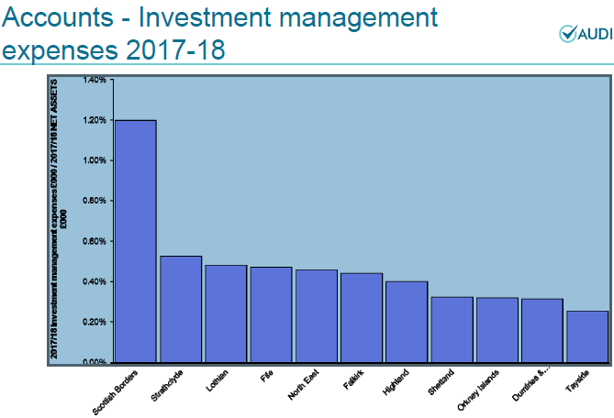
Furthermore having the second lowest administration and oversight costs as proportion of net assets
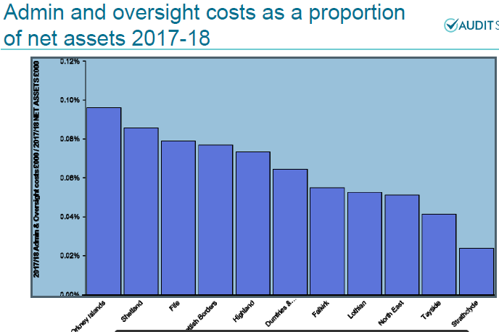
Whilst there are various figures being quoted in way of potential savings in investment management costs that would be achieved by merging into one large fund, these figures are assuming internal investment management, but do not provide insight as to impact on investment returns.
From the evidence above, there are lower investment costs as a proportion of assets in 8 of the 11 funds (only one of which has partial internal investment management, outsourced to another fund). Furthermore, in terms of administration and oversight, there is no huge correlation as to economies of scale that would have such an impact as to warrant fund merger.
In 2017/18, the following performance across funds was captured by Audit Scotland. From this it is clear that there are a range of returns, but these are in no way correlated to in-house, or larger schemes.
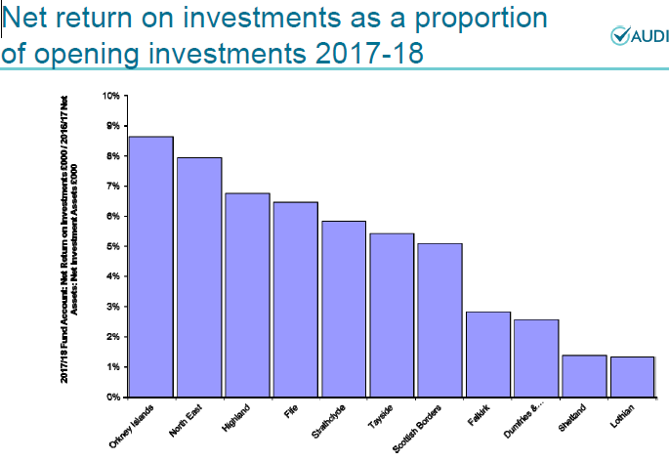
- Operating risks:
How well informed do feel about the operating risks of your fund? What information do you rely on to specify and measure these?
TPF have a detailed risk register which is subject to continual appraisal and quarterly review by the TPF Sub-Committee and Board. The risk register is publicly available both on the TPF website and within the minutes of the meetings on Dundee City Council website. The full risk register is also published within the Annual Report.
Whilst there is mooted that there are key person risk within smaller funds, TPF have sound and solid governance in place to ensure that there is adequate specialist resource available to assist if required, whether it be by senior officer, investment advisor or from support and guidance in the short term from other funds.
How well are operating risks managed in the current system?
TPF has a strong focus on the identification, analysis and management of risk. Investment and funding strategies are designed to manage specific risks, and controls are inbuilt into processes to ensure that risks are managed appropriately and proportionately.
Risk monitoring with investment managers (who are contractually bound to have robust compliance and risk management resource) is undertaken quarterly, and external analysis is also undertaken by investment consultants and auditors.
Having 11 funds in operation with differing investment strategies provides suitable diversification and risk management for the Scottish LGPS. The greater the fund size, the harder the task of diversification and thus the increase of risk to the membership of the fund. This is a key point that the managers of larger, successful funds such as Strathclyde point out as once too big the risk of diseconomies of scale grows as the bigger the fund, the more inflexible it is to manage.
How would you improve the measurement and management of operating risks in the current system?
Scheme benefits and the application of these are a key area which could benefit from improvement. The regulations associated with scheme benefits have over the years become more and more complex. At present there are in effect 3 benefit schemes in operation (1/80th, 1/60th, 1/49th) as well as numerous administering body and employer discretions available through the differing regulations. This complexity significantly increases operating risks associated with administering benefits.
The introduction of the cost cap which may result in further change to benefit regime will only complicate this further. TPF would support any means of simplification of LGPS benefits and discretions to enable greater standardisation in administration and thus better management of risk.
- Infrastructure:
How well informed do you feel about your fund’s investments in infrastructure? What information do you rely on?
TPF have ability within investment strategy to allocate 10% of fund to local and alternative opportunities, of which infrastructure forms part of. TPF have engaged KPMG (TPF investment advisors) to assess market conditions in line with the risk and return profile and requirements of the fund to develop a bespoke strategy to progress investment within this broader asset class.
How do you rate the current system’s ability to invest in infrastructure?
Infrastructure investment requires a sound understanding of risk, return and governance characteristics. Whilst there are funds who have particular experience in this area, most do not, so thus it is important to ensure that whatever solutions / vehicles are used to facilitate investment, they are appropriate for the specific investor and the fund’s requirements. In terms of size, TPF are not constrained as big enough to support large scale investment, but infrastructure is relatively illiquid, supply-constrained and expensive, so care and caution must be exercised.
How would you increase investment in infrastructure in the current system?
Investment in infrastructure would increase if the supply of attractive opportunities increased, or the risk/return characteristics were improved. More simple investment structures would also assist.
- Do you have any additional comments about this option?
It is worth re-iterating that the LGPS in Scotland is a success story. Funds have solid and stable management and their closeness to their own stakeholders has enabled investment strategies to be tailored to the needs of individual funds in meeting their liabilities.
This can best be evidenced in the funding position. The Scottish funds are all close to or above 100% funded meaning that their primary objective has been achieved. The LGPS in Scotland has for very many years been better funded than its equivalent in England and the rest of the UK. The GAD Section 13 report which analysed all Scottish funds on a standard basis demonstrates this strong position, but also that funds do not necessarily have to be big to be successful. The David and Goliath of Orkney versus Strathclyde shown below is testament to this.
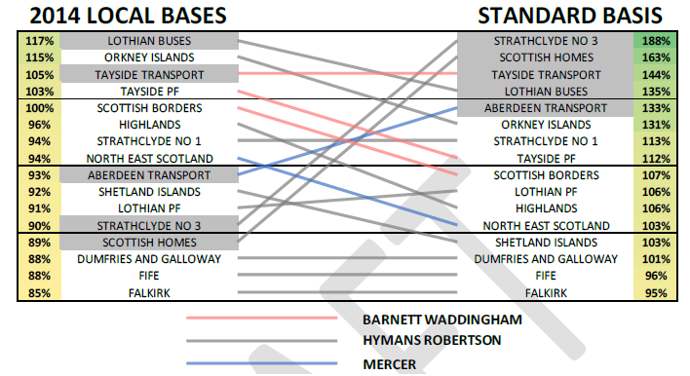
The scheme does face significant challenges in the current difficult pensions environment. A number of these are described in the SAB structural review report. Funds will need to adapt to address these, but these challenges do not stem from the current structure, and revising the structure is unlikely to be a panacea for them.

Question 2: Promote cooperation in investing and administration between the 11 funds
The text can wrap onto additional pages.
- Cost of investing:
What impact do you think promoting agreements between funds would have on investment costs?
TPF think that this is potentially the largest area that could deliver improvements both in terms of costs and in quality of performance.
Collaborative procurement across all investment services, based on incorporating potential for others to join if appropriate would ensure standardisation of investment fee rates (which may be an issue for smaller funds) and also cost sharing of generic requirements across all funds would also ensure consistency of information as well as removal of cost duplication.
What would be the positive impacts?
  - Financial savings (fees and services)
  - Better information to facilitate more informed decision making
  - Reduced resource requirements across all funds
What would be the negative impacts?
None.
- Governance:
What impact do you think promoting agreements between funds would have on governance?
No significant impact on individual governance structures, but may lead to better outcomes.
What would be the positive impacts?
Reduced duplication of governance effort. Improved collective governance of the scheme, creating a more collaborative culture across funds.
What would be the negative impacts?
No negative impacts, but the need to co-ordinate activity and decision-making could be a complication until such arrangements bed down.
- Operating risks:
What impact do you think promoting agreements between funds would have on operating risks?
None
What would be the positive impacts?
Could have positive impact in relation to managing risks across the funds.

What would be the negative impacts?
None
Infrastructure:
What impact do you think promoting agreements between funds would have on funds’ ability to invest in infrastructure?
  - Ability for funds without experience in alternative asset classes to benefit from the experience and expertise of others.
  - Reduced costs of legal, consultancy and due diligence required.
  - Standardised and potentially better quality information to facilitate more informed, and better decision making
What would be the positive impacts?
Potential financial savings, and facilitating wider diversification across asset classes
What would be the negative impacts?
None
- Do you have any additional comments about this option?
Significant co-operation between the Scottish funds and the wider LGPS network already exists.
LGPS (UK) National Frameworks are in place and are widely used for a range of services including actuarial, investment consultancy, stewardship, global custody, performance and cost monitoring, legal, transition management and third party administration services.
Scottish LGPS framework agreements have been put in place for portfolio management, member tracing, and scheme administration.
Introduction of LGPS 2015, and the associated member and employer communications, was a large-scale collaborative exercise between all the Scottish funds.
There is undoubtedly scope and willingness to build further on these initiatives.

Question 3: Pool investments between the 11 funds
The text can wrap onto additional pages.
- Cost of investing:
What impact do you think pooling investments between funds would have on the cost of investing?
TPF already enjoys significant benefits of scale and is effective in ensuring lowest cost investment fees as demonstrated in independent assessments by Audit Scotland, therefore TPF believe further efficiencies in existing mandates unlikely through adding further scale. TPF are of the opinion that pooling would be detrimental to investment strategy as it would result in limiting the ability to meet investment objectives as mandates are selected to complement each other in order to meet the required investment objectives of the fund in terms of risk and return profile of the actual TPF pension liabilities. There would be an additional layer of bureaucracy and cost, as well as a loss in ability to make the optimal investment decisions for the benefit of the funds members and employers. The complex pool structures in England and Wales demonstrate this additional bureaucracy and costs:
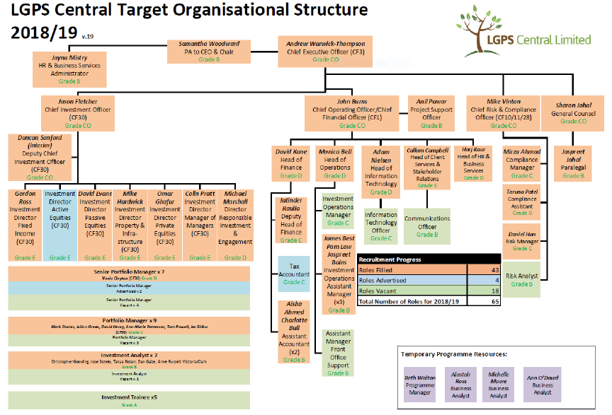
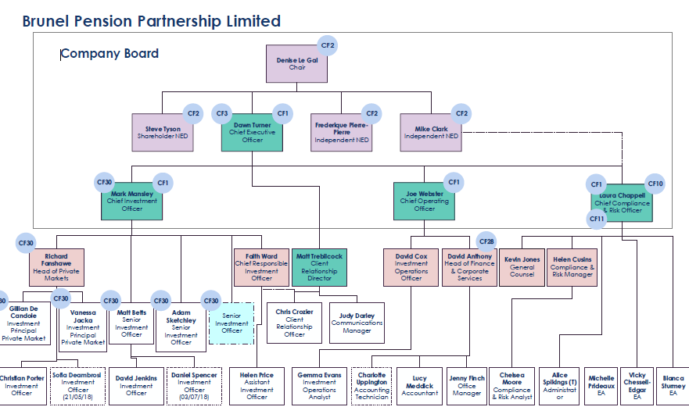
What would be the positive impacts?
TPF believe any positive impacts to be unlikely, but believe the costs to be significant.
What would be the negative impacts?
Reducing cost is only a positive impact if it improves net returns, and there is no evidence that costs have actually been reduced. Cost reduction through pooling would be a negative if it led to a restricted choice of investment options, and reduced returns or increased risk.
Some very attractive investment opportunities, particularly in private markets, have limited availability. A larger pool may be unable to achieve its desired allocation and is unlikely to achieve cost savings as managers have no need to offer cost incentives where demand outstrips supply.
The ultimate negative impact would be when restricted choice led to reduced returns and failure to best meet the investment objectives of the funds members and employers, and there was a detrimental impact on the funding level and subsequently on employer contribution.
Employers may not be able to accommodate any rise in contribution rates, and whilst a change in structure should not affect members’ benefits directly, if investment returns are significantly lower, this may occur (as has been the case for USS).
If asset pooling were possible, under what circumstances should a fund consider joining an asset pool?
A fund should only be embarking upon this arrangement if stakeholders unanimously believed that the decision to pool is in the best interests of their members to whom they have fiduciary duty to act in their best interest.
Under which circumstances should the SLGPS consider directing funds to pool?
If there was clear evidence that funds are unable to manage and failed to meet their investment objectives and there was potential for detrimental impact to members and employers.
- Governance:
What impact do you think pooling investments between funds would have on governance?
Where pools oversee external investment managers, this represents an additional layer of governance between the fund and the manager. It is likely to reduce transparency and complicate governance.

Where pools manage investments internally, the funds may become captive – i.e. it would be difficult to replace the internal management team if they underperformed.
What would be the positive impacts?
TPF do not consider there to be any potential positive impacts.
What would be the negative impacts?
  - Cost of set up and maintenance
  - Resource to establish and maintain
  - Loss of flexibility which could have negative impact in meeting objectives and ultimately in costing more to employers / and member benefits
- Operating risks:
What impact do you think pooling investments between funds would have on operating risks?
  - Pools with external managed funds - Potentially increased operating risks as there would be the existing operating risks of the managers, but then a new layer of risks associated with management of the pool.
  - Pools with internally managed funds – Increased risk management and compliance resources would be required to enable comparative effectiveness with external management (who are managing considerably more funds than LGPS, and have global resources and expertise to do so).
What would be the positive impacts?
TPF do not consider there to be any potential positive impacts.
What would be the negative impacts?
  - Financial cost
  - Detrimental impact on resources
  - Concentration of risk
- Infrastructure:
What impact do you think pooling investments between funds would have on funds’ ability to invest in infrastructure?
Very little, if any. Varying sized funds invest in infrastructure, it largely depends on the fund’s choice of investment.
Pooling investments might facilitate infrastructure investment by funds who currently don’t, but across the Scottish funds, the potential increase in allocation to this asset class would not materially change the total investment in infrastructure.
What would be the positive impacts?
Infrastructure investment typically does operate on a pooled basis – with investors pooling resources, usually through a limited partnership structure to increase their buying power and share risk.
A combined initiative by the Scottish funds to invest in infrastructure could have some merit.
The recent report by the Scottish Futures Trust (SFT) on Scottish Real Asset Investments and the Local Government Pension Scheme identifies an area of investment that “enables LGPS to meet their fiduciary duties with good risk adjusted returns that are not highly competed by other investors: as those investments are not highly competed for by other investors, investment in them will provide a level of additionality to the Scottish real asset stock, and where they relate to new developments, they will provide additional Scottish capital stock.”
It should be stressed, though that:
▪ the positive impacts identified by SFT are not related to the objectives of the LGPS and its funds; and
▪ it would not be necessary to pool funds in their entirety to facilitate investment in infrastructure. The creation of a pooled investment vehicle in which funds could invest would achieve this if the vehicle was sufficiently attractive on a risk/return assessment.
What would be the negative impacts?
  - Large set up costs
  - Potential FCA authorization requirement
Do you have any additional comments about this option?
It is much too early to judge whether the pooling initiatives of England and Wales have been successful in meeting their objectives, however what is clearly apparent that is that this has been a costly and time consuming exercise with no standardised approach or clearly planned strategy. The payback period for costs incurred is likely to span many years and it is also likely to be some time until the pools settle fully into their new structures as all pools differ in set up, structure and objectives.
The pooling of England and Wales has also had detrimental impact on stripping resources from administering authorities who still require skills and resources, therefore potentially increasing risk of detrimental impact in the management of the funds.
Infrastructure investment is not the primary objective of the LGPS, and thsu fiduciary duty must be considered if considering pooling the funds simply to achieve more infrastructure investment in infrastructure.
TPF do not support the approach used in England and Wales, but there might be some merit in more selective pooling, on a voluntary basis either of individual asset classes or by specific groups of funds, dependant on wishes of individual funds in order to meet their requirements.

Question 4: Merge the funds into one or more new funds
The text can wrap onto additional pages.
Cost of investing:
What impact do you think mergers between funds would have on the cost of investing?
Answer as for pooling at 3.a, above.
What would be the positive impacts?
Answer as for pooling at 3.a, above.
What would be the negative impacts?
Answer as for pooling at 3.a, above, but the transitional costs would be much greater.
Aware that changes to the structure could, however, affect employers directly – their contribution rates are impacted by investment returns and funding. The potential impact of “what could happen” is demonstrated below following 2014 valuation:
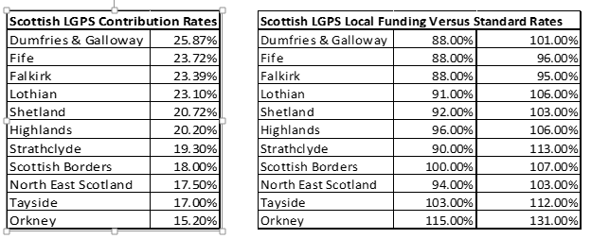
Fund employers would not be able to accommodate change to contribution rates, furthermore, and which would be as a result as a drop in funding level would not be in the best interest of the scheme membership.
In light of the above risks, TPF could not support any option which could result in an increase in contribution rates which would be unaffordable. A 1% increase in employer contribution level would result in an estimated increase in pension costs of up to £4m for some employers.
If merging were possible, under what circumstances should a fund consider a merger?
Any fund merger should only be considered if 2 or more individual funds (and their stakeholders) believe this option to be in the best interests of their members and employers.
Under what circumstances should the SLGPS consider directing funds to merge?
Answer as for pooling at 3.a, above.
Governance:
What impact do you think mergers between funds would have on governance?
Merger would inevitably reduce or remove local involvement in pension fund governance. The degree of this would depend on the model and extent of the merger.
What would be the positive impacts?
A merged model would require less governance resource than individual governance models, but this is only truly a positive if the merged model is more effective.
What would be the negative impacts?
A merged model would increase the reliance on a smaller number of individuals, and in so, significant increase in risk.
Operating risks:
What impact do you think mergers between funds would have on operating risks?
Fund merger would inevitably result in concentration of risk, and reduced diversification. However, if 2 or more funds did believe merger to be beneficial for their individual circumstances, this should still be a key consideration.
Whilst there are opinions of the potential savings a full merger of Scottish funds might may have, a fair point to note is that there have been no balance in assessing the impact of potential failure on the collective membership and employers due to the decisions of a reduced number of individuals. Size is no guarantee of success, and the impact of failure would be catastrophic for the country.
What would be the positive impacts?
TPF do not consider there to be any potential positive impacts.
What would be the negative impacts?
- Concentration of risk.
- Impact of failings
- Loss of flexibility
- Reliant on reduced number of people
Infrastructure:
What impact do you think mergers between funds would have on funds’ ability to invest in infrastructure?
A full merger of Scottish funds could increase investment in infrastructure, but only if the investment strategy required this. Investment strategies are set to meet risk and return objectives, not to facilitate an investment in a favoured asset class.
- What would be the positive impacts?
A merged fund or funds could potentially make larger individual investments.
What would be the negative impacts?
Larger individual investments would represent a greater concentration of risk.
Do you have any additional comments about this option?
At the extreme, merger into one fund would be likely to break the direct link between the scheme and local government by taking the fund out of local government control.
Whilst a fund of this size would undoubtedly enjoy benefits of scale, size is not a guarantor, nor necessarily a determinant of success.
The UK’s 2 largest pension funds are the Universities Superannuation Scheme (USS) and the British Telecom Pension Scheme (BTPS). Both have assets of around £50 billion (a little more than the combined value of the Scottish LGPS funds). Both are very well managed in many respects. Yet both have significant funding deficits – in excess of £10 billion in each case – and are contemplating, or have effected closure of their schemes to new defined benefit accrual.

Question 5: Preferred and additional options
The text can wrap onto additional pages.
- Which option does your organisation prefer? Please explain your preference.
Tayside Pension Fund (TPF) already enjoys considerable benefits of scale in terms of cost which is demonstrated by the independent annual reviews undertaken by Audit Scotland. TPF has in place an appropriate and effective governance structure and risk management processes.
It is not clear what would be gained by members or employers from the proposed alternative models of pooled or merged funds. It is certain, though, that there would be significant costs and risks associated with any change, and any pooling or merger of funds should only occur where individual funds are in agreement that this would be to the benefit of their members and employers. TPF has a low contribution rate based upon the localised asset and liability profile of the fund, its underlying funding position and bespoke investment strategy, and whilst protection would be sought to retain this should the pooling or merger option be chosen as the optimal structure, there is no guarantee that any future investment strategy determined at larger scale would sustain this. The risks that a change of structure that could result in a rise in employer contribution rates, and in turn a potential change in benefits would not be supported by TPF as this would not be in the best interest of its scheme membership. Pensions provision is a very long-term undertaking, and structural development should be clearly focused on the long-term sustainability.
TPF’s preferred option is to develop a more collaborative structure (option 2) which could generate advantages across all funds without disruption, transitional cost and likely unintended consequences that merging or pooling would produce.
The Scottish LGPS has established communications networks between funds (both investment and administration), but current focus is largely on information sharing and problem-solving rather than structural development. TPF would welcome the opportunity to collaborate in areas such as investment opportunities; procurement; ESG & governance issues; administration.
- What other options should be considered for the future structure of the LGPS?
The LGPS in Scotland has a good existing network of communication between funds, but its current focus is largely on information sharing and problem-solving rather than structural development. Some reorganisation of this would be required in order to support co-ordinated development. This might include the following:
- development of a forward-looking programme to consider potential initiatives such as:
  - joint investment, including in infrastructure
  - joint or framework procurement
  - joint or shared diligence
- joint engagement on environmental, social or governance issues
- shared communications and administration (e.g. GMP) where applicable.
- a regular, formalised meeting of fund conveners
- What would be the advantages and disadvantages of these other option for funds’ investment costs, governance, operating risks and ability to invest in infrastructure?
Development of the structure on a collaborative basis as suggested above, could generate many of the advantages of the individual options identified without the disruption, transitional cost and likely unintended consequences that selecting and mandating one option would produce.
- Are there any other comments you would like to make?
Pensions provision is a very long-term undertaking, and the prime objective is to act in the best interest of the members in order to meet their requirements, therefore any structural change should be clearly strategically focused on the long-term benefits of the members rather than any external objectives.

The consultation questions end.

