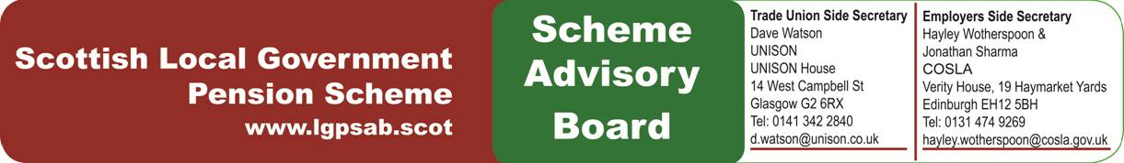

Scottish Public Service Pensions Governance Review

SLGPSAB response

Introduction

- The SLGPSAB broadly welcomes the governance review and will give careful consideration to its recommendations. We also note the intention of The Pensions Regulator (TPR) to publish further guidance.

- The new governance arrangements have been in place for a relatively short period of time and this includes a learning curve for all the participants. It is therefore very early to draw firm conclusions on the operation of these arrangements.

Roles and Responsibilities

- In the current financial climate facing local government it is inevitable that SLGPS pension boards will be focusing on oversight of pension funds. In addition, there has been a need to respond to member, political and public interest in investment strategies, as well as cost transparency, which is reflected in work on the transparency code and the recent FCA report. This does not mean that good governance and scheme administration is given insufficient consideration, it simply reflects priorities in the relatively short period the boards have been in operation.

Training

- We agree that all LGPS pension boards should have an annual training plan in place and that members should undertake the Pensions Regulator on-line training as part of their induction. We are not convinced that it necessary for training logs be submitted to the SLGPSAB.

Support for Boards

- We believe that SLGPS pension boards already have support from dedicated staff and agree that agendas and papers should be issued in sufficient time to allow preparation time.

- SLGPS pension boards are not council committees and certainly not sub-committees of the administering authority’s pension committee. This status may well mean that arrangements for publishing papers create a different administrative challenge. It is also a feature of the unique SLGPS governance structure that pension boards work in partnership with council pension committees. However, we agree that some common publishing standards are appropriate and the SLGPSAB website should include more information on pension boards.

Board Composition

- The SLGPS is the largest pension scheme in Scotland with a wide range of stakeholders. We do not believe that a membership of 14 is too large or reduced its effectiveness. The current term for members generally is four years and we agree that this provides greater stability than the shorter period in other boards. In practice, board members may relinquish office for a variety of reasons during this period therefore formal succession planning may be unnecessary.

- The model of rotating chairs was given careful consideration at the time the SLGPSAB was established by the stakeholders and Scottish Ministers. It is well understood in local government and as the review notes operates effectively at pension board level. We can see no evidence presented in the review in favour of changing this model. Consistency with other SABs that operate in a very different context falls considerably short of a compelling case.

- We agree that gender balance could be improved and nominating bodies should be asked to reflect this in their nominations. As far as pensioner members are concerned, the review may not have been aware that they are included in the representative structures that underpin the trade union side membership of boards and play an active role. It is the case that the relative risks in the LGPS means that there is a presumption in favour of representation from contributing members, but this dooes not mean that the interests of retired members are ignored.

- The SLGPSAB has provisions for professional advisors and these arrangements work well. The SLGPSAB has a significantly higher workload than other boards and we will keep under review the need to allocate additional resources as required.

Board Interaction

- We agree that there should be greater interaction between SLGPS pension boards and the SLGPSAB. This has already been raised with us. As the review notes there is a tradition of this in the SLGPS, but we accept that this could be strengthened. The sharing of minutes, attendance at meetings and an annual pensions conference are sensible recommendations. Given the significant differences between funded and unfunded schemes, it may be that separate conferences would be more appropriate.

Conclusion

- Overall, we welcome the evidence in the review that stakeholders believe that the current arrangements are generally working well. However, the new arrangements have had only a limited time to bed in and therefore we should keep these matters under review.

Joint Secretaries
March 2017

